Lesson 1 Demo 3: Pod Creation

This section will guide you to:

* Create pods using a yaml file

This lab has two sub-sections, namely:

1. Creating multi-container pods
2. Creating a single container pod

**Note:** If you don’t have an existing Kubernetes cluster, refer to the Demo 1.1 of Lesson 1.

**Step 1:** Creating multi-container pods

* On the **master** node, create a new file named **sample.yaml**:

*vi sample.yaml*

* Add the following code in the **sample.yam**l file.

*apiVersion: v1*

*kind: Pod*

*metadata:*

*name: multi-container*

*spec:*

*terminationGracePeriodSeconds: 0*

*containers:*

*- name: nginx*

*image: nginx:1.10-alpine*

*ports:*

*- containerPort: 80*

*- name: alpine*

*image: alpine:3.5*

*command: ["watch", "wget", "-qO-", "localhost"]*

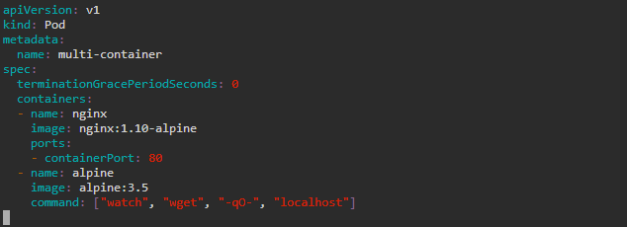

**Note:** Press **Esc** button and enter **:wq** to save and exit the text editor

* Use the following command to create the **multi-container** pod

*kubectl create -f sample.yaml*



**Step 2:** Creating a single container pod

* On the **master** node, create a single container pod with a tomcat image using the following command:

*kubectl run tomcat --image=tomcat:8.0*



* Check all the running pods

*kubectl get pods*

